Employees Provident Fund Organization has launched Universal Account Number (UAN) based ‘Member Portal’ to provide a number of online services to all employees through a single window, such as online PF transfer / withdrawals etc. Kindly find attached the notification issued by Employees Provident Fund Organization on 29th Nov 2018. Stating that Aadhaar has to be seeded as a KYC to UAN. This notification confirms Aadhaar is mandate for UAN activation and KYC updation even after the Supreme Court Order dated 22nd Oct 18. So this makes above activity very important for you to complete UAN information for any PF formality.

We have attached the UAN number related documents below for your convenience.

ONLINE PF TRANSFER:

In order to make online PF transfer, please ensure the following.

I. The member should have activated his UAN in UAN portal and mobile number used for activation should also be active

ii. Bank account and bank IFSC code of employee should be seeded against the UAN Seeding Aadhar number and PAN against UAN is not mandatory for raising transfer claims.

iii. The employer should have approved the e-KYC

iv. The previous/current employer should have digitally registered authorized signatories in EPFO. Also while initiating the online pf transfer request, please select the claim attestation throughout present employer for approval.

v. PF account number of both previous and current employment of an employee should be entered in EPFO database. If previous PF/ EPS number is not linked with UAN account, than employer can manually enter the previous pension number in GET MID option, as mentioned in STEP-4

vi. Only one transfer request against the previous member ID can be accepted

vii. Personal information (Name, Gender, Father Name, DOB) and PF account related information is shown in EPFO should be correct. Also its required previous employer DOJ, DOE / DOL and current employer DOJ should be available in portal.

PF transfer Steps:-

Step 1

Login to Unified portal (member interface) by using your credentials i.e., UAN number and password

URL: https://unifiedportal-mem.epfindia.gov.in/memberinterface/

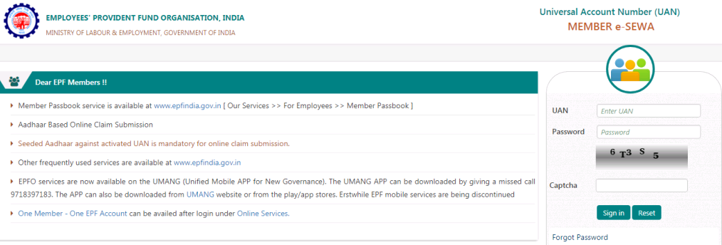

Step 2

After login, click on ‘One Member – One EPF Account (Transfer Request)’ under Online Services

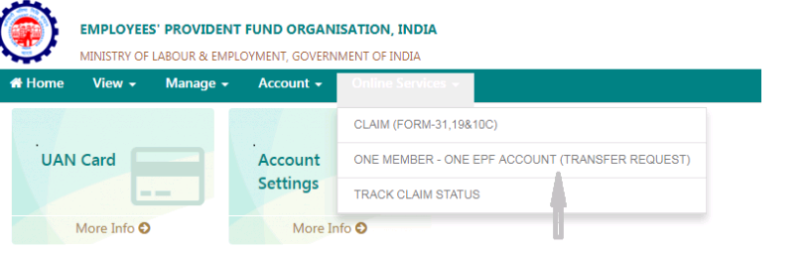

Step 3

Verify personal information and PF account for present employment:

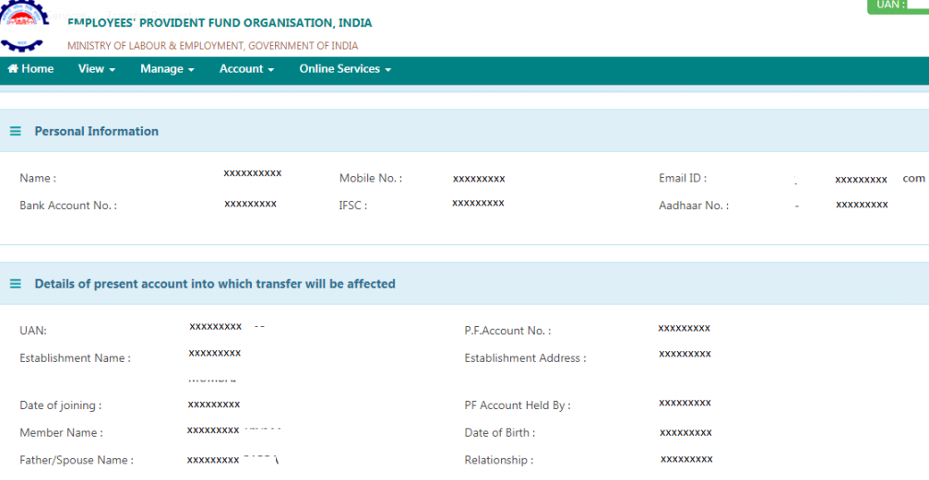

Step 4

PF account details of previous employment would appear on clicking on ‘Get details’ below.

Note:
- If employee previous PF / member id is already linked with UAN account, then you can directly mentioned UAN account number in below column and click on Get Details for select the employer. So that respected employer information will be appear in below window.

B If previous pf number is not linked with UAN account, than please click on GET MID option and update the PF number manually and click on Get details for view the information.

C If employee previous company PF amount was kept maintained by internal TRUST / Pvt Trust, than please mentioned the previous Pension (EPS) number in GET MID tab for receive the previous employer PF details accordingly.

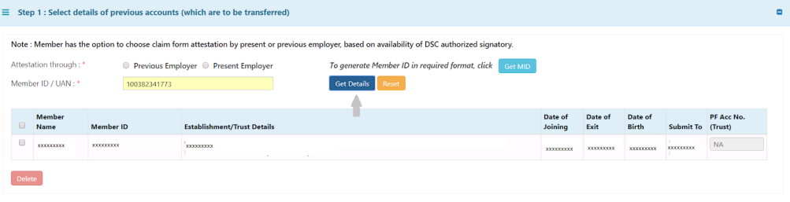
Step 5

You have the option of choosing either your previous employer or current employer for attesting the claim form based on the availability of authorized signatory holding DSC. Kindly select the current employer approval and update the previous employer member id/UAN:

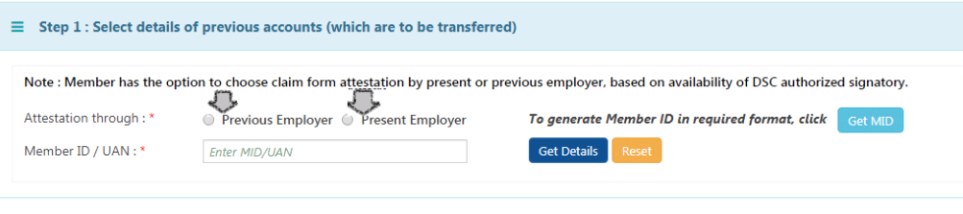
Step 6
In the next step, click on ‘Get OTP’ to receive OTP to UAN registered mobile number and enter the OTP and click on submit.

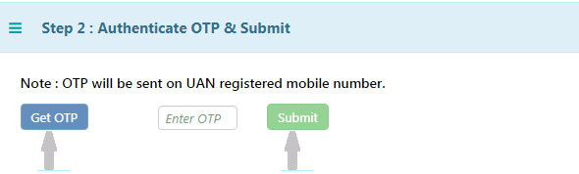

The employer will digitally approve your EPF transfer request by accessing employer interface of the unified portal

After submission of the online transfer request in UAN portal, kindly collect the printout of the online generated form 13 and send the attested scan copy to EB.Socialsecurity@accenture.com
For approval.

NOTE: We will approve your claim in 8 to 10 days and after approval it usually takes 2 to 3 months to the amount to be credited to old PF account to new PF account by the PF department.

